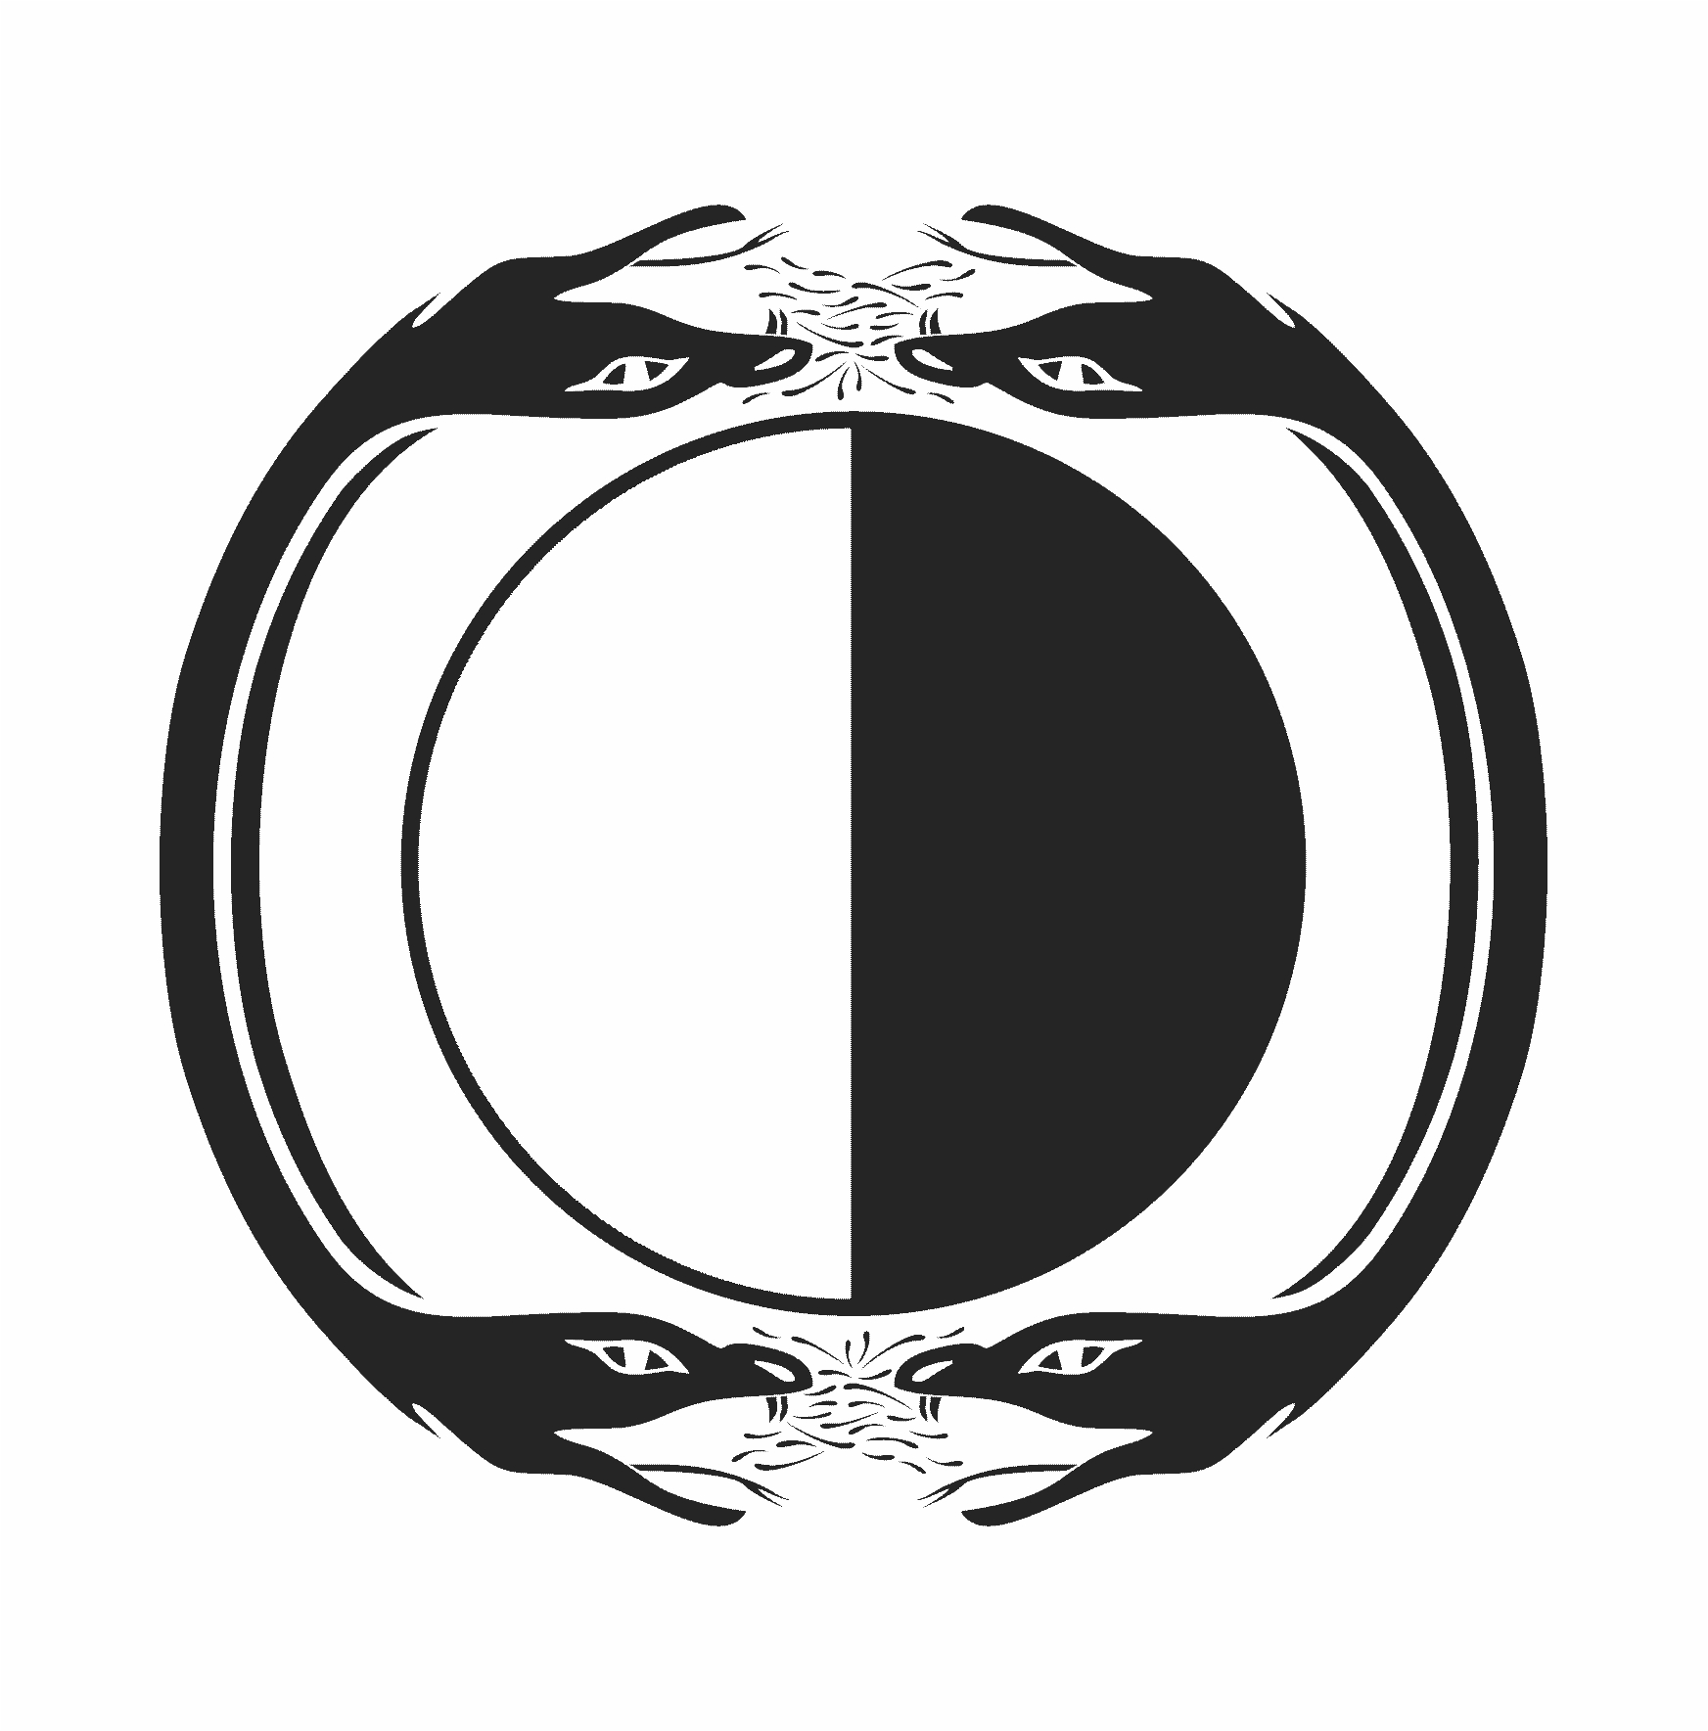
Good vs bad for dummies?
Dogoodism as a tool to keep people down

- the left/right
good/bad
right/wrong
- where it is EITHER/OR
where one has to “fight for peace”
where one is supposed to make “good” win over “bad”
- heaven/hell=after life ?
- duality
- symbolically = a circle divided into black&white
contour = 2 two headed snakes hissing at each other at top&bottom

The paradigm of “western civilisation” based on monotheistic mass-religions & industrial food&goods production is coming to a climax now we have exported it worldwide (economic globalism)

it shows us the urgent need for a different paradigm:

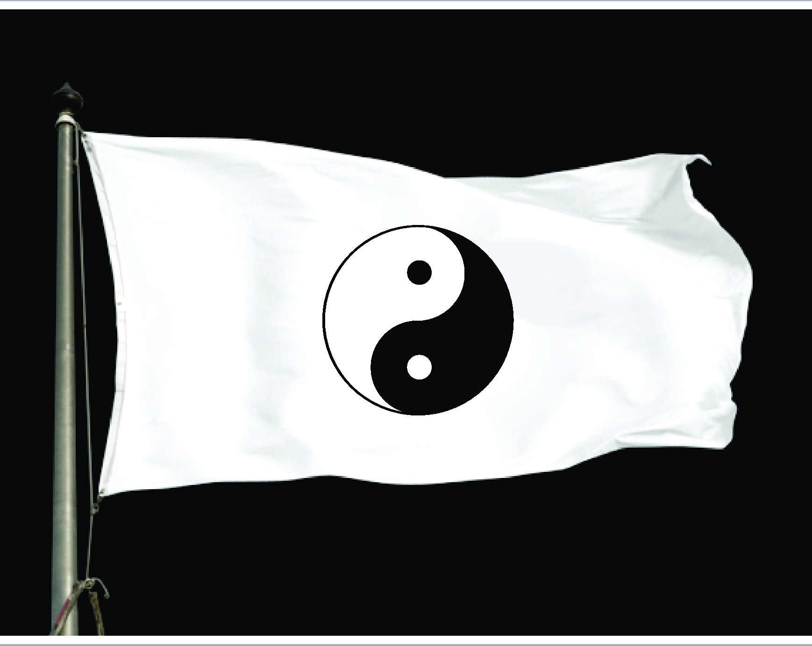
the yin-yang symbol
where there is white in the heart of black
& black in the heart of white
extreme yin turning into yang & vice versa
polarities intertwining like the DNA-coil
life as an eternal phenomenon
where every stick has 2 ends
where it is AND+AND+…
non-duality
where inner peace is the only way to outer peace
where living well this life is the spiritual mission
of each living entity
symbolically = yin yang symbol
contour = a snake biting its own tail (ourobouros)

monotheistic religions, based on holy books inevitable lead to fundamentalist exclusivism
whatever the “founding father” intended is transformed into a system to control humans from inside their heads (perception-censoring) & hearts (emotional weakening)

when in power =
- open prosecution of self-chosen masses of “enemies” (gypsies, jews, socialists, muslims, blacks, geeks, indians, …)
- open indoctrination through compulsory manipulated schooling (jesuit rule of elites)
- open nepotism for handpicked protégés&hereditary strawmen in office
- open persecution/inquisition of scientists&whistleblowers&non-conformists

when not (yet) in power =
idem but hidden under the pretence of “privacy”, “classified”, “secret”, ….
milking its “flock” for power to be used against any “enemy” p.e. fascist anti-communism

Dualistic non-tools
Group discussion of what these words mean nowadays
Hero-ism | Common-man-ism
Absolute-ism | shock&awe-ism
Saviour-ism | Personal development
State-ism | Violent Anarch-ism
Heaven-ism | Humble-ism
Conform-ism | Anti-conformism
Victim-ism | Terror-ism
Guilt-ism | machismo
Solution-ism | Capital-ism
Tool-ism | Expert-ism
Know-ism | “wirhabenesnichtgewusst”-ism
Fasc-ism | Commun-ism
Escape-ism | National-ism
Tour-ism | Race-ism
Sex-ism | Sensual-ism
Succes-ism | Outcast-ism
Elite-ism | Popul-ism
Scept-ism | Spirit-ism
Exclusiv-ism | Universal-ism

Non dualism in a table
Opposition vs integration=group discussion
Opposites clash | Opposites are complementary
Separation of vital components | Respect for nature as a mutual eco-system
Live for a future to be “made” | Be here now&create the circumstances for a durable future
Impose your will by brute force(fossil fuels, nuclear, bulldozer, weapons, ...) | Seek integration op polar opposites with minimal disturbance of existing equilibriums
I know//i do//i choose to ingore | Design with continual feedback, reciewing results
Waste is what is not efficient for NOW | One process' waste=another process' resource
I take what I can | Human stewardship of earth=global responsability
Exclusive focus on what I master NOW | measuring=global context for longer-than-huùan-life-perspective
Linear ana-lysis | Circular synthesis
Colonialism, extraction | Global co-evolution
Perceive from I-me-mine&short term | Perceive from eternal life energy
knowledge | wisdom

Code of conduct needed = if you live outside the law you must be honest
pitying vs empathy

